Title
Bookly: Book rental system

Technical Description
This system will contain features like real-time sorting and searching of customers and books.
Admin can Add/Delete customers with business rules like if the customers want monthly, quarterly or annual membership they must be at least 18 years old otherwise there will be a validation error.
Basic CRUD operations will be included.
Web API Integeration
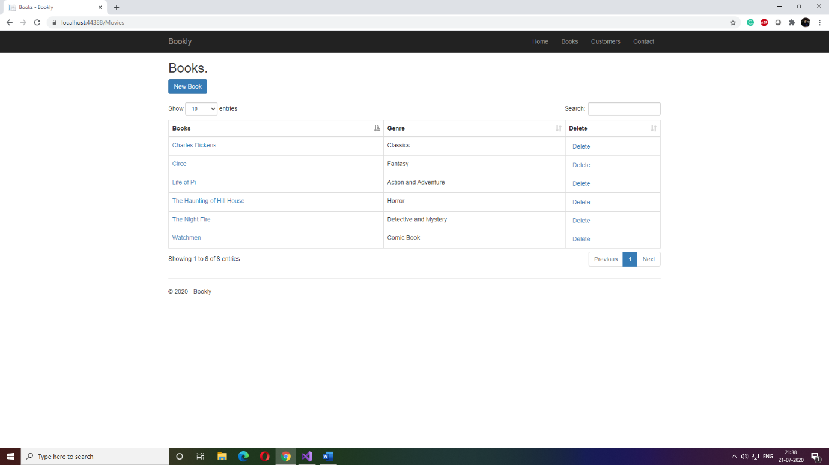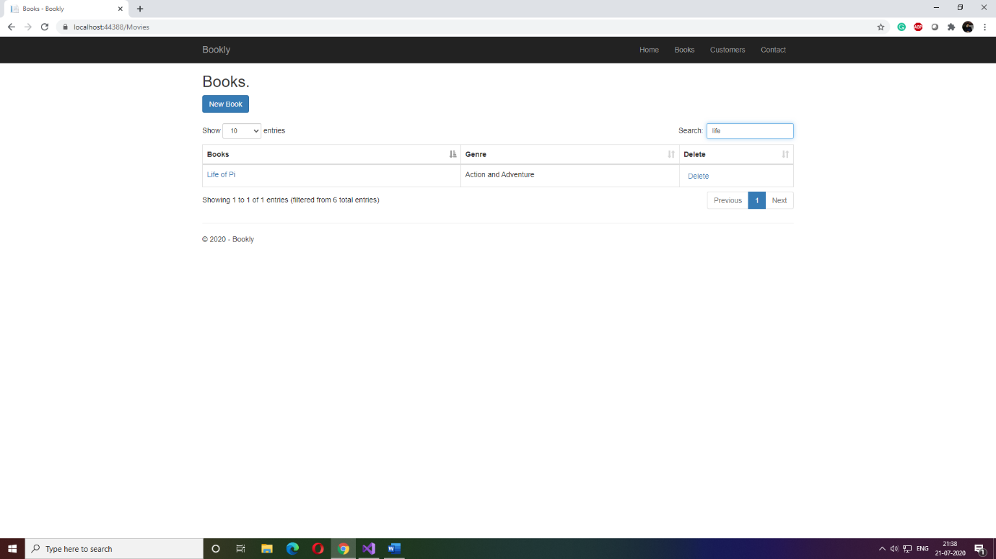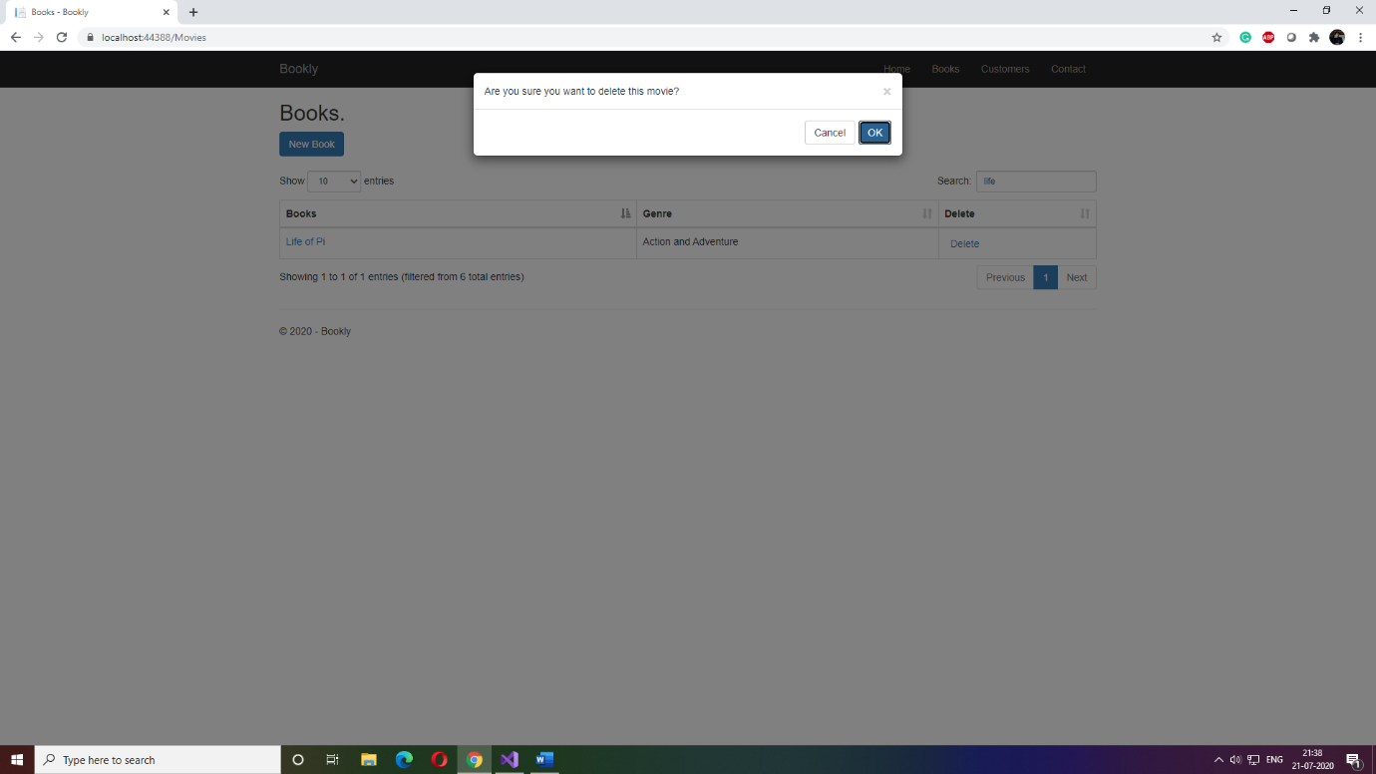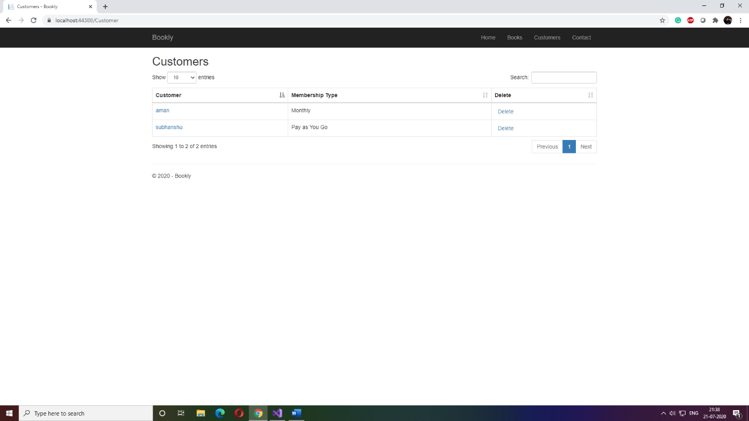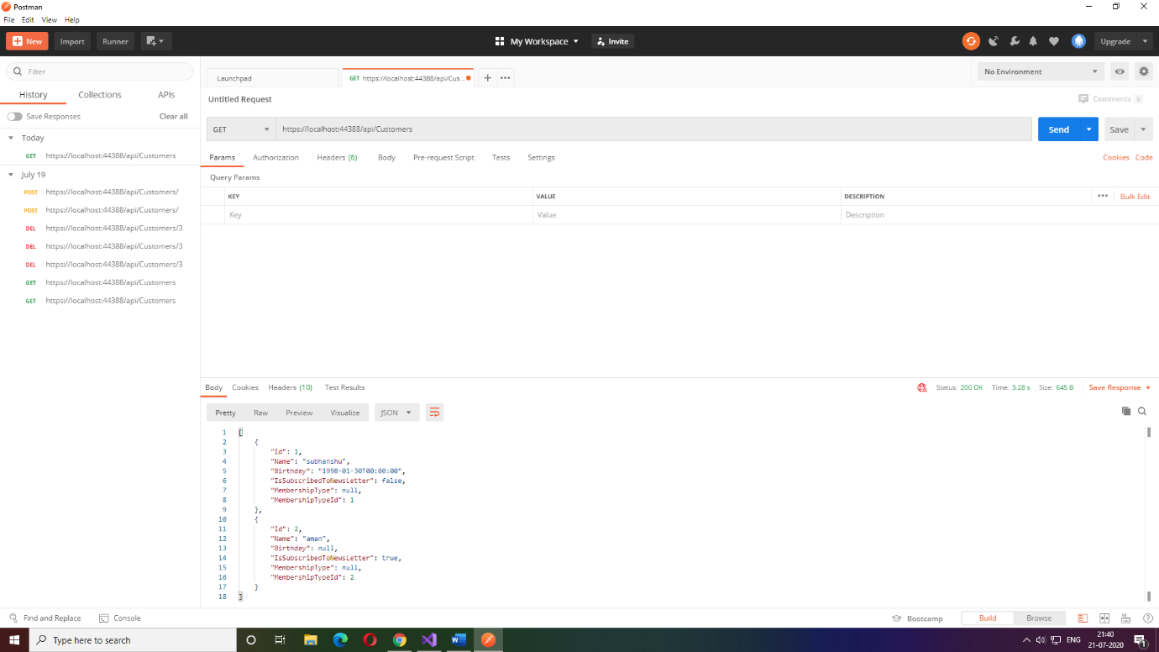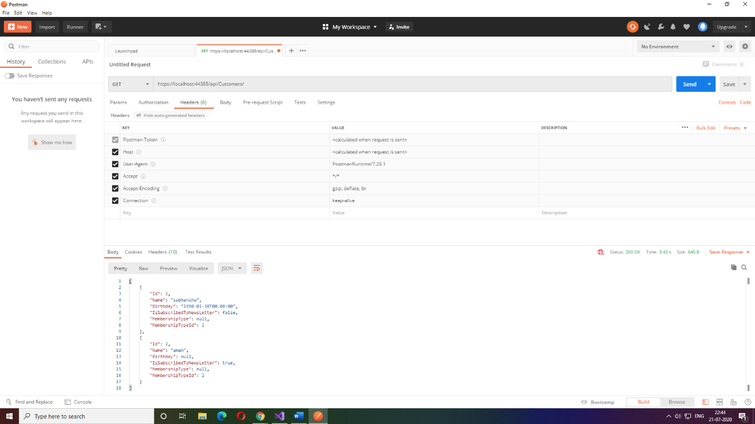

Technology
Dot Net

Purpose
This application can help in automating a bookstore it takes care of records and its management.
It also maintains security by limited access to staff.

